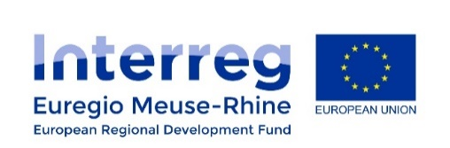
Blood-compatibility testing of the polymer

The Poly-Valve project (Polymeric Prosthetic Heart Valve for Life) from the Euregio Meuse-Rhin Interreg programme is ongoing. This project is mainly focusing on conducting medical research regarding artificial heart valves, aiming at providing long life, tailor-made heart valve prostheses using polyurethane. A close collaboration between the Maastricht University and Liege University led to the production of a polymer with low thrombogenic properties.
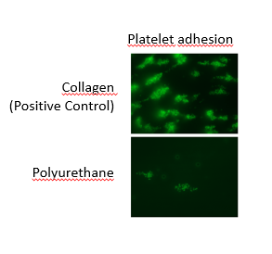
Maastricht University optimized a method to test the thrombogenicity of a polymer under flow and was able to test different polymers designed by Liege University. They assessed platelet adhesion and coagulation activation on the surface of the polymers.
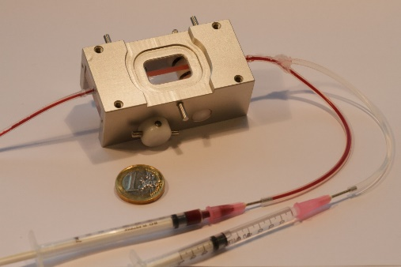

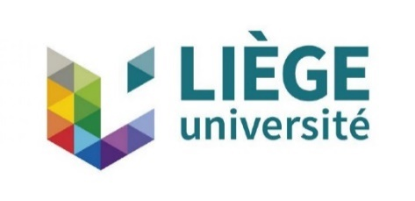
The polymer with the lowest platelet- and coagulation-activating properties will be used to develop a heart valve by means of molding technology.

